COMMISSIONERS:
STAN VANDERWERF (Chair)
CAMI BREMER (Vice-Chair)
HOLLY WILLIAMS CARRIE GEITNER LONGINOS GONZALEZ, JR

Facilities and Strategic Infrastructure Management Services
Facilities ~ Parking ~ Americans with Disabilities Act (ADA)
El Paso County Title II of the Americans with Disabilities Act
Request for Accommodation or Barrier Removal
This material can be made available upon request in an alternative format as required by the Americans with Disabilities Act of 1990. For further assistance, you may direct your request to the ADA Coordinator listed below.
Name of Person Filling Out Form Individual Needing Accommodation
Name: |  | Name:
Address: |  | Address:
City: | Zip | City: | Zip
Phone: | Email: | Phone: | Email
Signature: |  | Signature:
Date Submitted:

Please list the facility, program, service, event, or location for which you are requesting accommodation or barrier removal:
Date(s) the Accommodation is Needed:
What is the specific accommodation you are requesting?

Additional comments and/or relevant documents may be attached
Please return the completed and signed form to:
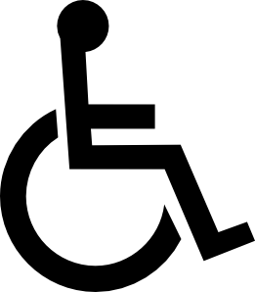

David Mejia
El Paso County
Title II ADA Coordinator
325 South Cascade Avenue
Colorado Springs, CO 80903
ADACompliance@elpasoco.com
(719) 520-6866

325 SOUTH CASCADE AVENUE, COLORADO SPRINGS, COLORADO 80903 ♦ OFFICE: 719.520.6556 FAX: 719.520.6111 WWW.ELPASOCO.COM

